Picasso Style Self Portrait
Cheri Lee Keefer
Iolani School
5th or 6th Grade

Students will create a self-portrait using Picasso's Cubism style.
Objectives:
Students will:
-be aware of the expressive qualities in their own portraits, characteristics that stand out.
-be aware of Picasso's artwork and incorporate his style into their own portrait.
-be aware of the difference in Realism vs. Abstract artwork.
-be aware of how lines, shapes, and color create a visual rhythm.
-draw a self-portrait using Picasso's Abstract Cubists style.
-be able to use chalk pastels to enhance the drawing with color.
-be able to communicate conversation about the artwork viewed.

Vocabulary: Materials:
Portrait pencil and eraser
Abstract Art mirrors
Realism white drawing paper
Cubism chalk pastels
line paper towel
shape finishing spray
color
background

The students were first shown the video "Dropping in on Picasso,"
By Crystal Video. The video was reviewed with discussion about many of his works of art. I shared a bulletin board showing a variety of his portraits. Many books on Picasso were passed around the tables to share. One of my favorite books is "Picasso" by Carsten-Peter Warncke.
The students were very excited to begin but felt confused on abstraction. Students want things drawn to look look like the "real thing!" The challenge was on!!!!!!!
12" x18" sulfite white drawing paper, pencils, and erasers were handed out. The students studied themselves in the mirror (with many
giggles) to find an unusual characteristic to personalize the art work.
Drawing began. Students made many returns to the drawing board, books rechecked, and lots of thought before the final approval came to begin with the chalk pastels. The students placed paper towel under their hands and arms to keep the chalk from smearing while working. Students were encouraged to look at their work and emphasize rhythms with repeated colors and outlining. The finished composition was coated with a light spray of clear spray paint to keep the pastels permanent.
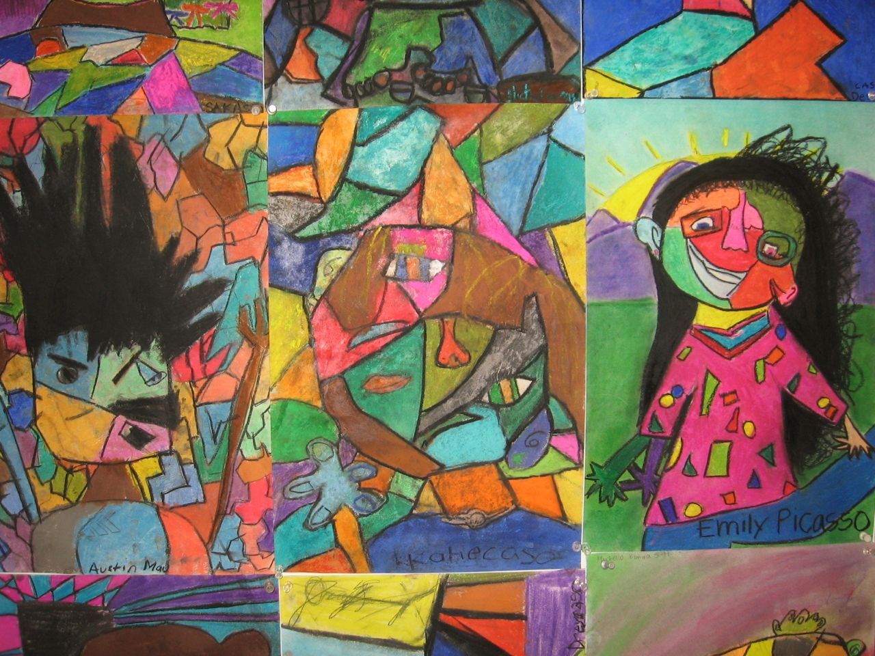

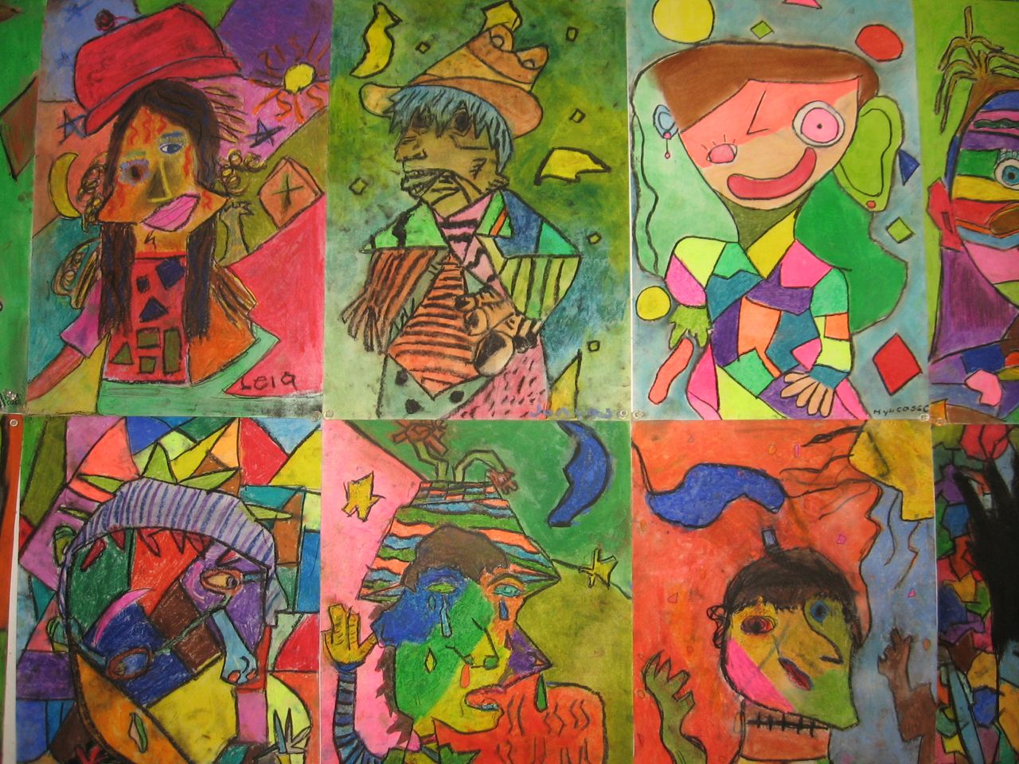
This "Hands-On" art project took 5-6 hours periods (55 mins.) including the evaluation/assessment. The evaluation/assessment consisted of a class discussion while the students shared their works with peers.
My personal grading philosophy is:
Did they pay attention to the video and take part in class discussions? Use materials properly or experiment in techniques demonstrated? Were excellent craftsmanship skills exhibited?

Have fun with this one!!! I had them sign their name with "caso" at the end.

