A. Light Painting Digital Photography

B. Alyce Walcavich

C. Douglas Anderson School of the Arts Jacksonville, Florida

D. Grade Level 10-12th (maybe younger)

E. Procedures:

Resources/Supplies
Digital Camera at least 6MP with a B setting capability
Tripod
Flash lights and (or) Flash units
Photoshop program (CS2-3-4)
Printer and Digital Photo Paper
Colored tissue paper
Darkened room location (a room you can make dark)

Teacher Discussions/Introduction of Project
Discussion with visuals on the topic of Light painting
Procedure on set up of camera and lights.
Students receive a project sheet and procedure page.

Student Participation
First stage: Students photograph
Students set up cameras in groups of 3 (one is the director and
photographer, one acts as a model, other operates the lights) Group
rotates until all have photographed. Each are required to take 20
exposures. We had 3 stations with cameras set up in 3 different
rooms)

Second stage: Download and do contact sheet
Students download their images into their personal student folder
on the computer share drives. (For each digital project I have them
create a new folder.) I have them make a contact sheet of these images
to turn in with project. (Photoshop has a contact sheet program under
File> Automate> Contact Sheet ll)

Third Stage: Work on image and print
Students work on these images in Photoshop. They are required to
improve contrast, composition/cropping/positioning, altering color,
and distracting detail or background. They were also required to
combine several of the images together in a triptych arrangement.
I approve work before they can print the final version. We use an Epson
Photo printer that has an output size of 12” x 18”.
Procedure Page

Camera settings: With Lights On
Attach camera to tripod securely
Have model in place
Set camera to M setting and turn control dial to B setting
Set Focus to the Manual focus setting (not auto focus)
Set Focus range to infinity or focus on model
Make sure flashlights and flash units work
Optional: attach colored tissue paper over flashlights
With lights off:

Photographer has to give instructions to student operating the
lights.
Hold the shutter open while the student paints with the light.
Try a variety of movements with the flashlight, as outlining
the contour of the figure, circular, zigzag, or bursts of light.
Have the model move at each burst of light. Try different light locations as front, side and back. Try to get the model to interact with the light. Experiment! Play! Try different colored tissue paper over lights.
Review the results. You may find that you need the shutter
opened for a longer period of time.
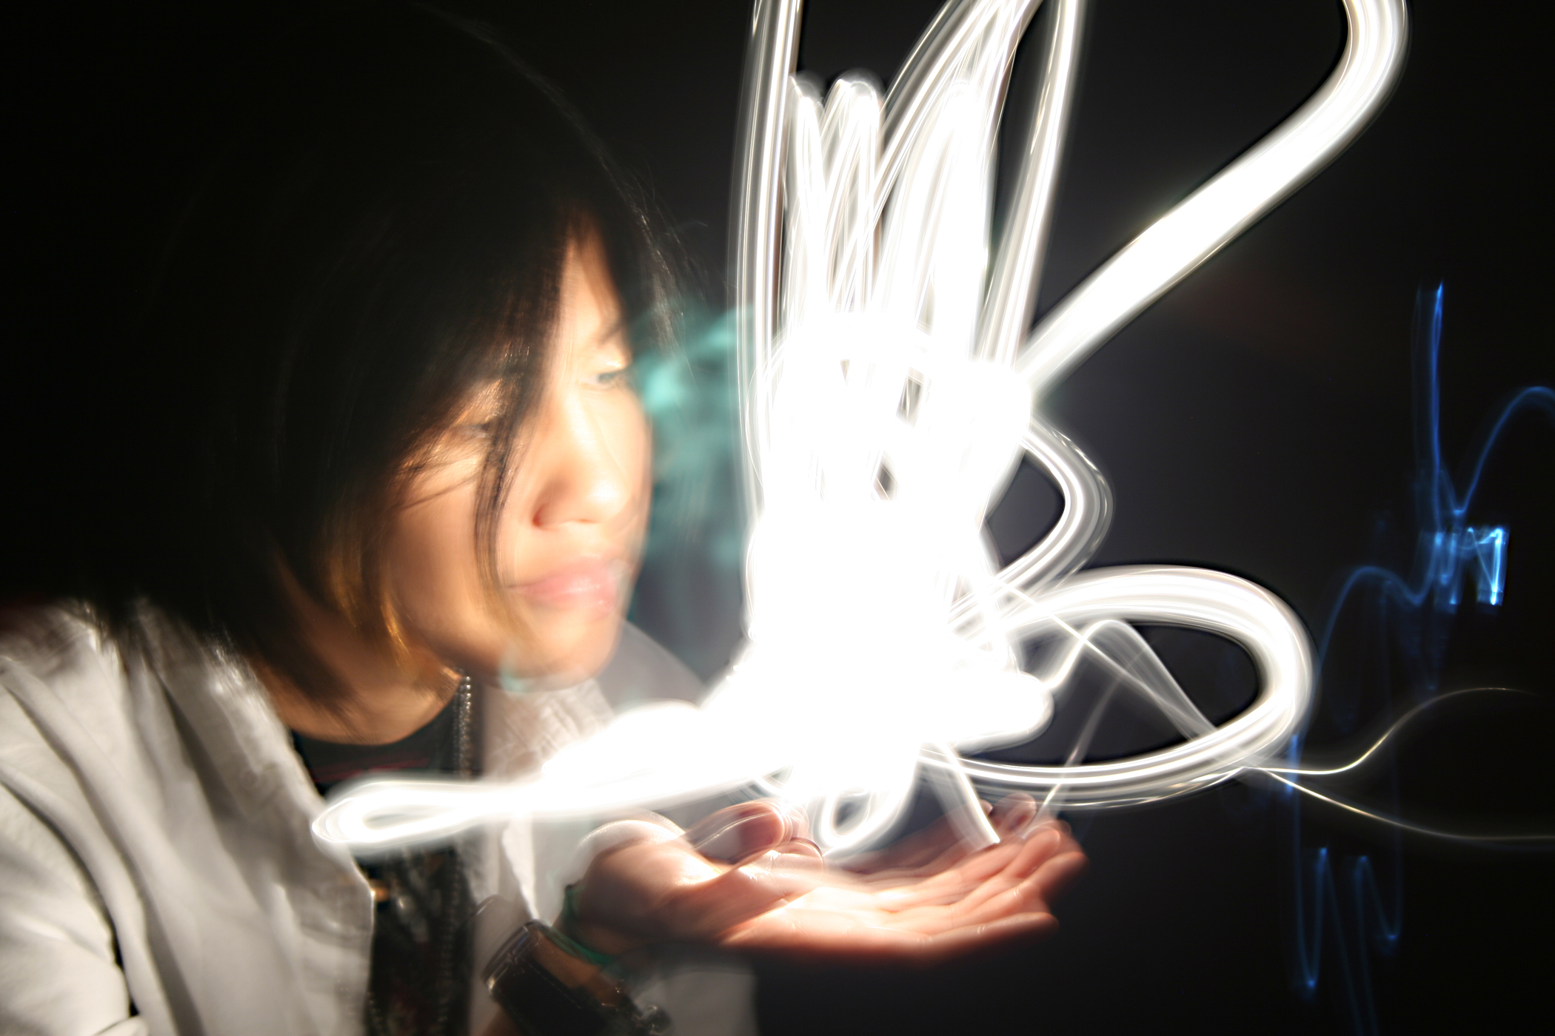
You can delete!
Must have at least
20 exposures


